To start the project, I decided to consume articles discussing general video game development. This research prior to the practical development of the project gave me time to create, develop and establish ideas.

Articles generally refer to sizeable video game companies such as Rockstar or Activision and how they have a ‘pipeline’ for organising the flow of work. The ‘pipeline’ generally refers the process at a whole of developing a complete video game. I noticed this process remains unchanged throughout the articles I selected.

One article by Nadia Stefyn stated that **[1]** “*the pipeline is not necessarily a linear process*”. What I believe Stefyn means by this is that projects, especially relating to game development, continuously change throughout the development cycle. Furthermore, once an idea is established, such as mine, factors such as functionality and design change for the better during development.

Researching articles helped me establish a solid plan of development which I aim to slowly illustrate through project planning software such as Jira. In my case I feel this is detrimental for the success of my project. For instance, most projects consist of several people that confer and collaborate, whereas this is an individual project for me, so in order to stay on plan and to manage my time appropriately I have noted I need to put forward *‘issues’* on Jira which I can then use to refer to throughout my project.

Documentation is one of the most important parts of game development. This includes the project planning as I’ve discussed, but also often game design documents (GDD)’s. These game design documents essentially map out the design of the game. After creating one of these documents as coursework for a previous module, I feel I have developed a good understanding of the purpose of these documents. As Stefyn quoted in her article **[1]** “*A Game Design Document is essentially the game's north star. It’s a living document which helps everyone understand and get on board with the greater vision of the project.*” I feel that this summarises the significance of planning. Stefyn means that once a project is laid out in black and white, we have an easier time comprehending what needs to be completed.

As part of the documentation for my project I drew a few preliminary sketches. This helps visualise my ideas relating to how I aspire to design the project. The initial illustration – the menu system **[2]** – illustrates a few action buttons which have various different operations such as the top two switching between game states.

**[2]**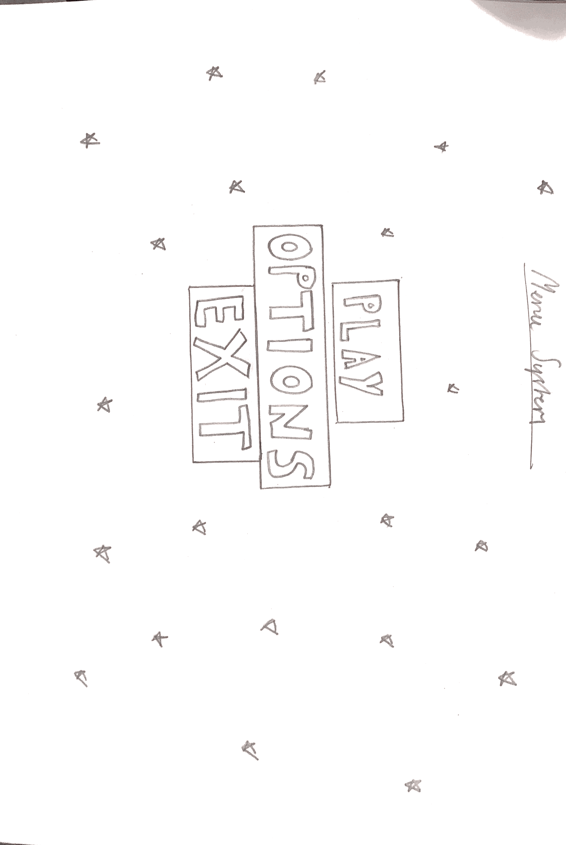

This second illustration **[3]** represents active gameplay. The player here is the spaceship with the surrounding asteroid objects being enemies. I am currently not sure which direction I want to take the sprites – however this is not problematic as they can be interchanged throughout the project. This is partially why developing a sprite sheet loader is one of my initial priorities as you will see discussed further within the report.

**[3]**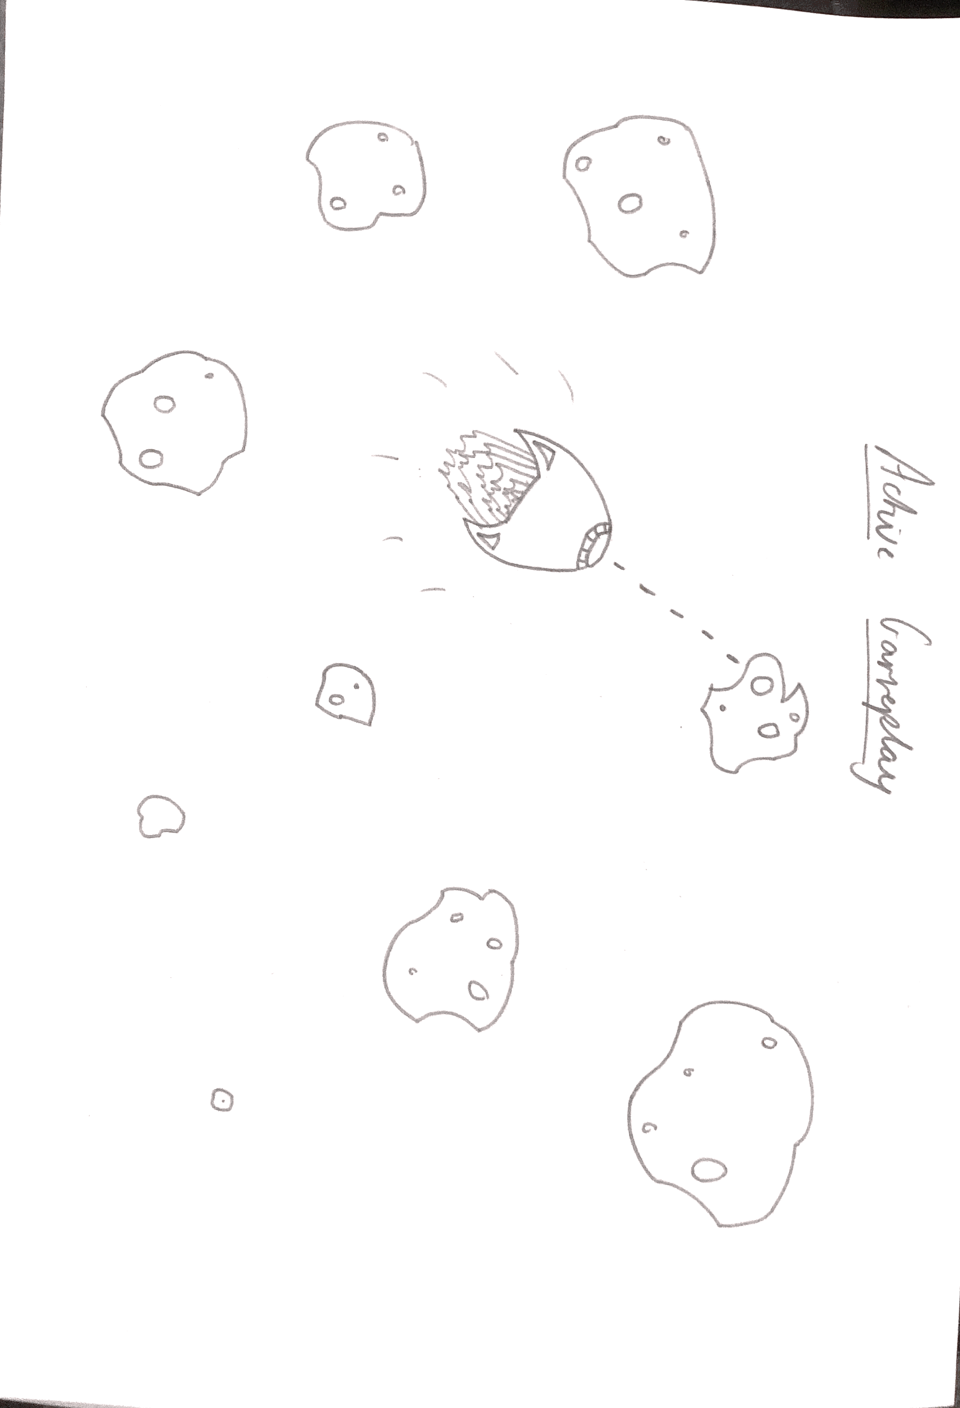

The last sketch **[4]** I designed portrays a scoring system for players. I believe this sketch is true to representation as it displays all the relevant information needed by a player after ending their session. It features a table which notifies the user of their position in the high-scores compared against players previous attempts.

**[4]**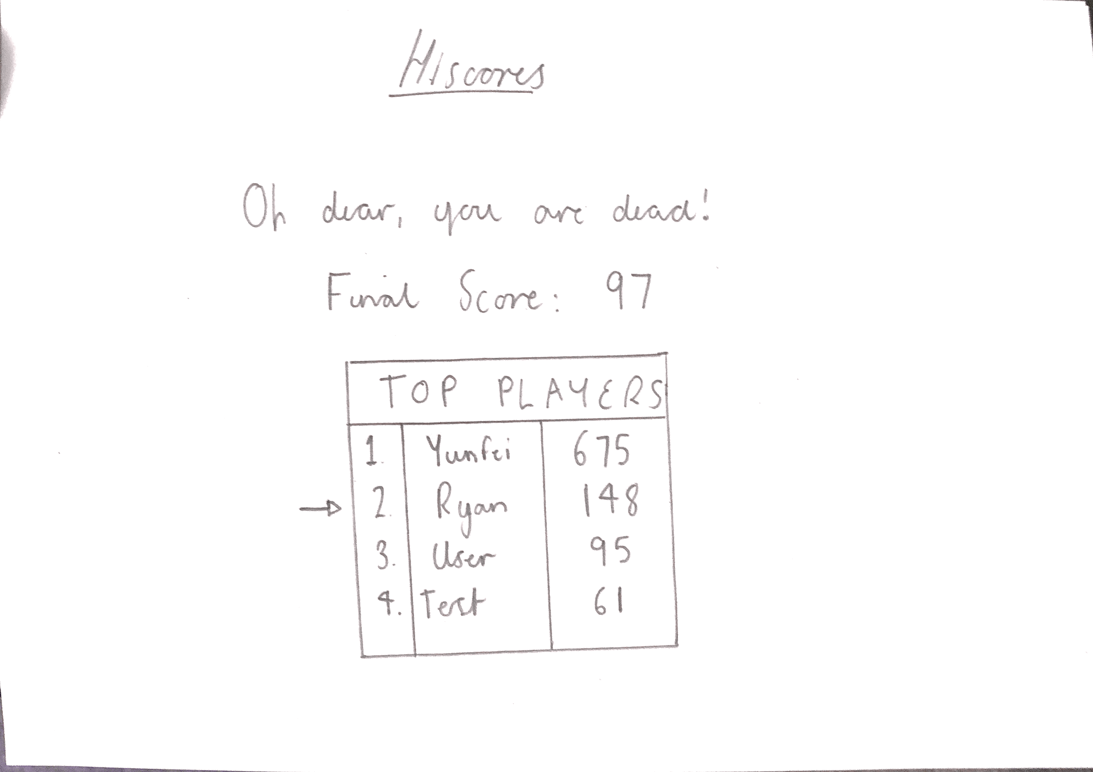

Upon expanding on my idea through analysing research articles, I created a mind-map of all the existing functionalities which I aim to implement into my project. I found this extremely useful as I actively refer and actively implement new ideas. As evident in figure **[5]** I have expanded some of my ideas illustrating what I plan on designing.

**[5]**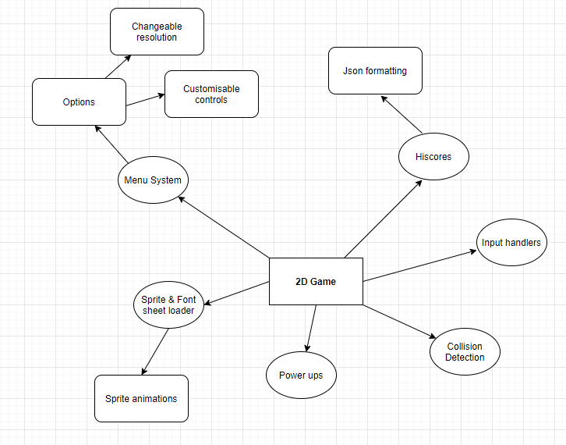

This brings me to the next part of my background research; this part revolves around the technical aspect of the project. This is type of research is practical based and provides me with solid sources to reference back to throughout the development stage.

A large part of my research and background reading was based around the technical side of the project relating to Java and how I would begin to develop the game application. Throughout my previous years at university I have spent a significant portion developing games for various modules. I feel from this I can understand to a significant degree what is required of me in order to achieve my set goals. These goals can be found on Jira.

In figure **[6]** I have illustrated a game from one of my modules last year. The purpose of this game was to gather understanding and knowledge on how to paint and maneuver objects within Java – this knowledge is applicable for my project. The player object is controlled through keyboard controls using a basic key manager implementing Java’s default Key Listener. Furthermore, I had randomly generated enemy objects, assigned them with a Y-velocity for movement and then spawned them off-screen.

**[6]**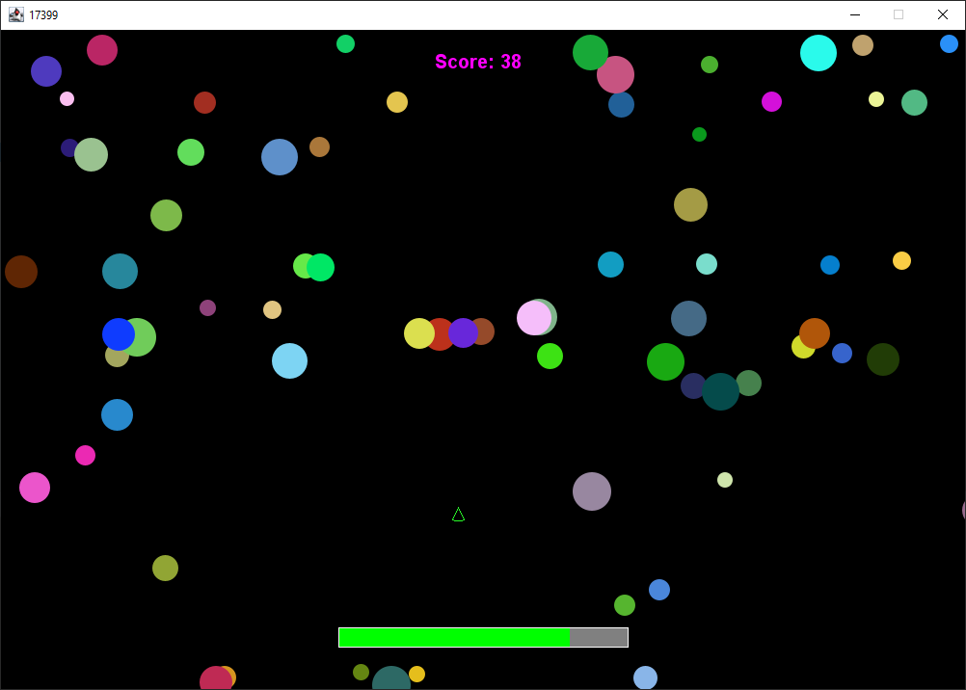

Additionality I had created another game throughout second year as part of one of my chosen modules. I found this game to be a huge improvement over my initial game project. This game had a lot more features packed into it - including a menu system, high scores, and a custom font and sprite loader. I have included this as part of my background research for several reasons. One reason is that it has helped me considerably advance my understanding of Java.

A lot of the features I plan to add to my Capstone Project I have previously programmed within these projects shown in both examples. Looking over these projects and noticing the improvements from the initial game to the one presented in figure **[7]** helps me now understand the future improvements I need to make in order to create and design a successful project.

**[7]** 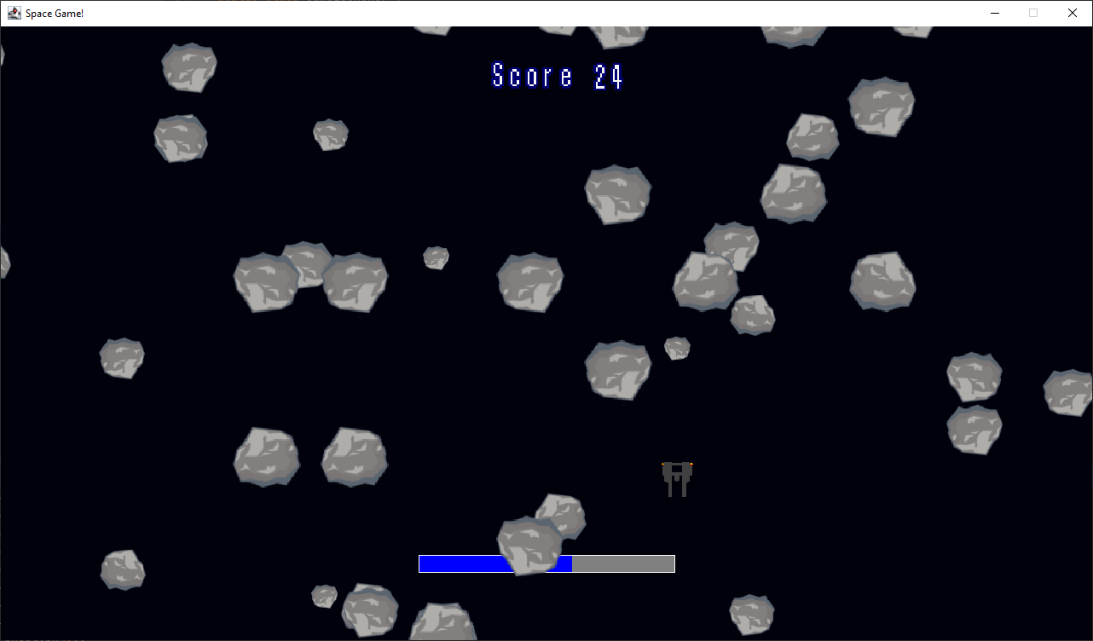

One issue that has remained consistent throughout the gave development history I have is collision detection. I found that I struggled with creating suffice object interaction throughout the projects which can lead to the game feeling ‘buggy’. Throughout my extensive background reading one important source I found was a website aimed at intermediate programmers **[8]**. This website discusses and teaches general practices needed for 2d game developers. The author(s) illustrate how they decided to program collision detection within their application. They break down the tutorial discussing various methods they implemented or used from Java’s Swing library. When I approach the stage of collision development throughout in my project, I will refer to this source to make possible improvements or changes.

**References**

**[1] -** [CG Spectrum: How Video Games Are Made: The Game Development Process](https://www.cgspectrum.com/blog/game-development-process)

**[2] -** [Jira - Menu System Sketch](https://cseejira.essex.ac.uk/secure/attachment/31450/Scannable+Document+2+on+16+Oct+2020+at+18-43-18.PNG)

**[3] -** [Jira - Active Gameplay Sketch](https://cseejira.essex.ac.uk/secure/attachment/31449/Scannable+Document+3+on+16+Oct+2020+at+18-43-18.PNG)

**[4] -** [Jira - Hiscores Sketch](https://cseejira.essex.ac.uk/secure/attachment/31448/Scannable+Document+on+16+Oct+2020+at+18-43-18.PNG)

**[5] -** [Jira - Time Scale](https://cseejira.essex.ac.uk/secure/attachment/31431/time-scale.png)

**[6] -** MY OWN GAME IMAGE

**[7] -** MY OWN GAME IMAGE

**[8] -** [ZetCode: Java 2D Games Tutorial](http://zetcode.com/javagames/)